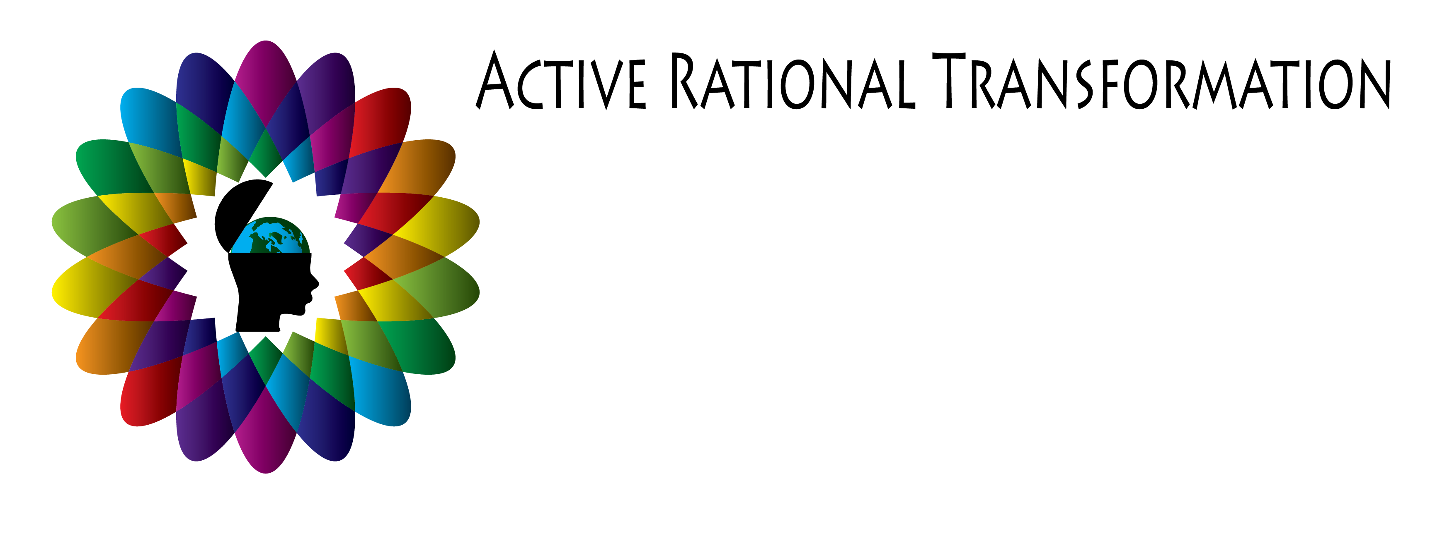

Module 10

Your Review Exercise

With these questions I would like you to reflect shortly on your journey and become clear what your most important takeaways are.

1. Please write down what was important for you to realized, to learn and to change:

I also invite you to look into the future and answer the following question:

2. What do you know is important to keep in mind going forward?

With Gratitude,
Martina

